# Sunburst Visual

Today, we are going to look at a new custom visual - MAQ Software’s Sunburst Chart. This visual allows users to display the breakdown of hierarchical data using color coded concentric rings. It is displayed as a radial treemap or as a multilevel pie chart. Clicking on the arcs results in an animated zoom effect focusing on the category and its lower levels.

# Key features:

The key features of the visual are as follows:

* Customizable arcs
* Proportional ring size
* Total value and detail labels
* Customizable detail labels
* Zoom-in animation
* Customizable data colors
* Cross-filtering support for legend values and circles
* Bookmark support
* Custom report tooltips support
* Drillthrough

Users need to provide data for three mandatory fields: Category, Subcategory, and Measure.

The Category field has the category values for Sunburst Chart. It is used to color the arcs as per various values of categories in that field.

The Subcategory field has the lower category levels.

The Measure field accepts numeric values to map to the category values.

Once mandatory data fields are in place, the visual is rendered.

**For demo purposes, we have included the following data in the data fields:**

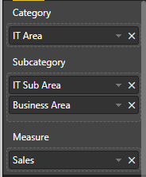

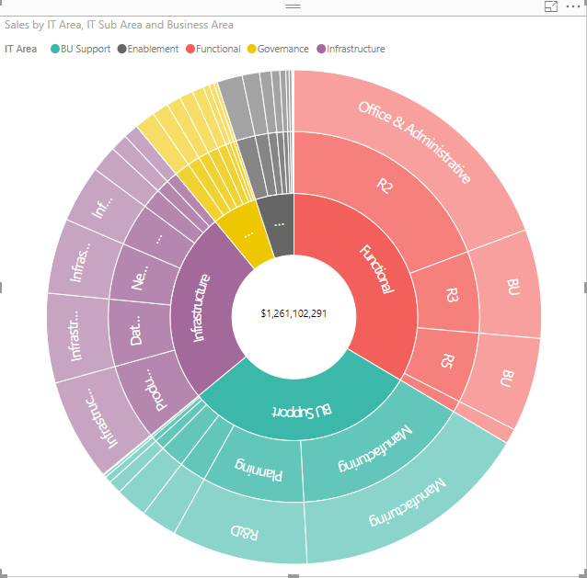

This will help us analyze the sales distribution across IT Area, IT Sub Areas, and Business Area.

Let’s look at the different features of the visual:

## Legend:

1. The legend shows the color of each IT Area. Users can show or hide the legend.
2. Users can change the position of the legend to the top or bottom of the visual.
3. Users can change the label color of the legend items.
4. Users can change the legend text size.

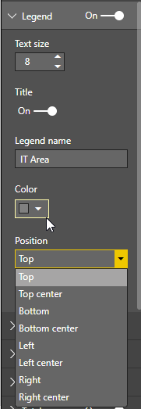

## Data Colors:

Users can also change the colors by which each IT Area is represented.

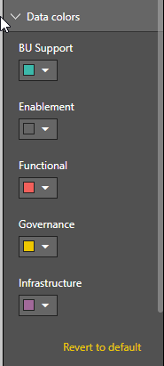

The data colors for the groups are customizable in the format pane in the Data colors tab.

## Data labels settings:

Users can change the Data labels settings in the formatting pane.

Data labels on the arcs indicate the IT Area, IT Sub Area, or Business Area that it represents.

In the formatting pane, users can choose to enable or disable data labels by turning the toggle “On” or “Off.”

In the formatting pane, users can choose to change the Color, Text size, or Font family of data labels.

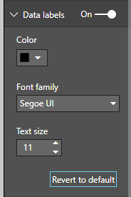

## Detail labels settings:

Users can change the Detail labels settings in the formatting pane.

In the formatting pane, users can choose to enable or disable Detail labels by turning the toggle On or Off.

In the formatting pane, users can choose to change the Color, Text size, Display units, Decimal places, and Label style.

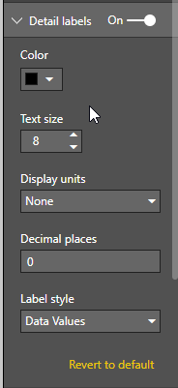

To determine the percentage contribution of various Business Areas by IT Area and Sub Area, choose Percent of total from Label style. To show percentage and value, choose Data value, percent of Total.

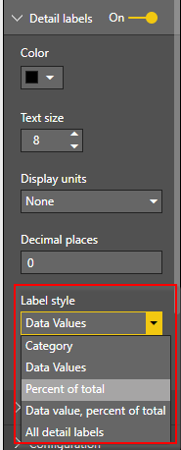

## Total label settings:

Users can see a total value of all the sales in the central area of the chart.

Change the Total label setting in the formatting pane.

In the formatting pane, users can choose to enable or disable total labels by turning the toggle On or Off.

In the formatting pane, users can choose to change the Color, Font family, Text size, Display units, and Decimal places.

The text displayed along with the total value can also be changed.

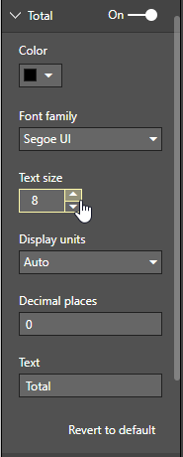

## Configuration:

If users want more space for labels, Radius can be reduced to adjust the display ratio between the chart and the labels.

Users can change the radius of the circle from the formatting pane.

To further enhance the look of the visual, users can adjust Corner radius, Padding between arcs, Stroke color, and Central circle fill.

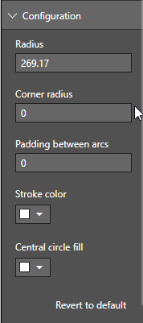

## Animation:

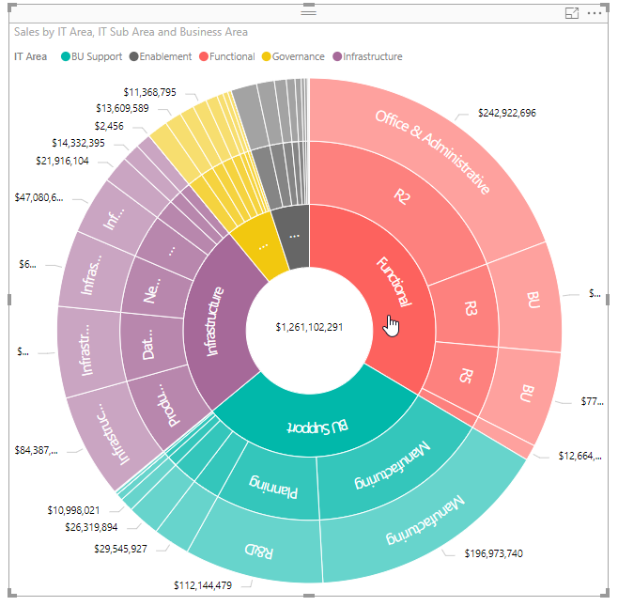

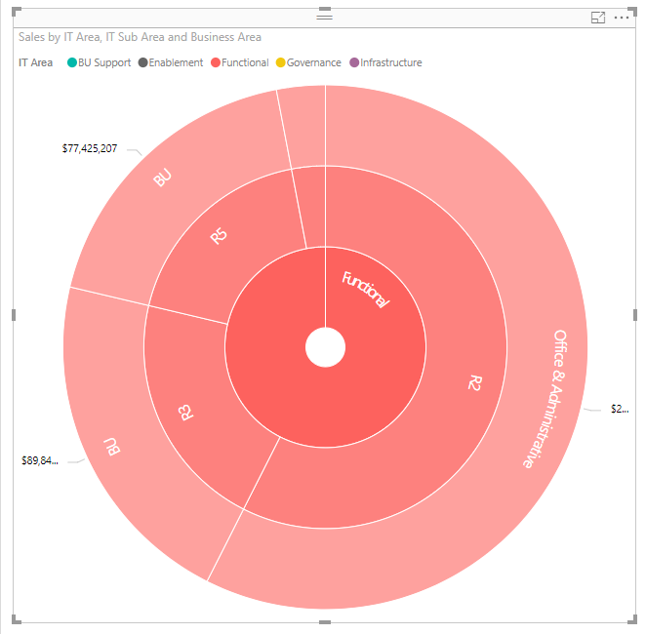

To zoom in on the Functional IT Area, click on its arc. The chart will now display information pertaining to the Functional IT Area only.

To return to the original state, click on the central circle.

To focus on a specific IT Sub Area, click on its arc.

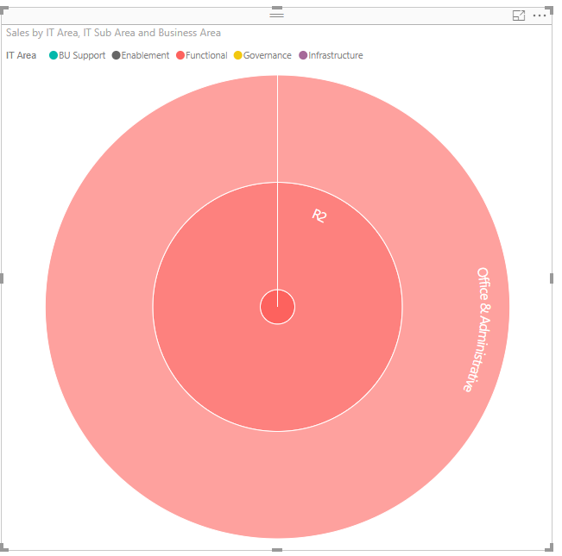

For example, click on the R2 subarea of the Functional IT Area.

Clicking on the central area will now zoom out by a level and focus on the corresponding IT Area.

Click again on the central area to return to the original state.

In the formatting pane, users can choose to enable or disable animation by turning the toggle On or Off.

If the toggle is Off, cross filtering takes place.

If the toggle is On, animation takes place.

# Conclusion:

Thank you for watching our video. If you have any questions about this visual or need a similar business solution, feel free to contact MAQ Software at sales@maqsoftware.com.